Question 1 - Implement JWT Authentication in ASP.NET Core Web API Step 1: Initializing the Project Structure
Step 2: Adding a User model and a login endpoint (code snippet)

Step 3: Generating a JWT token upon successful login (code snippet)

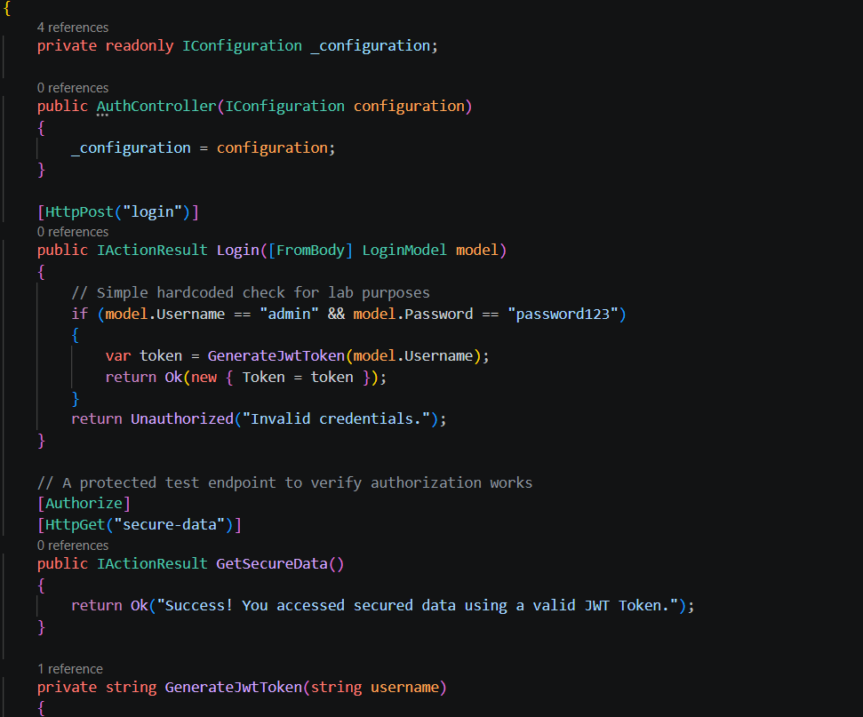
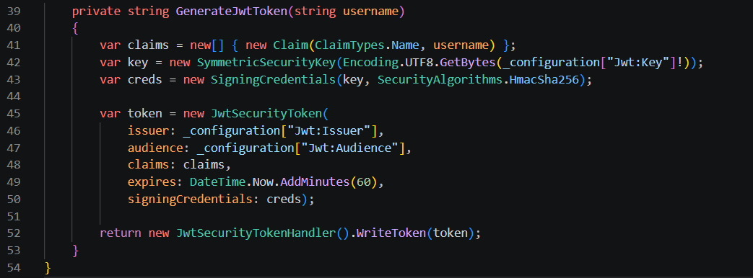
Step 4: Secure an endpoint using
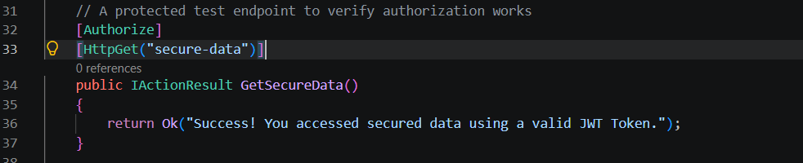
AUTHORIZATION OUTPUT USING TOKEN:
